CNST 418 Group 5 Conventional Munitions Maintenance Facility Alaska
Contractor Scope
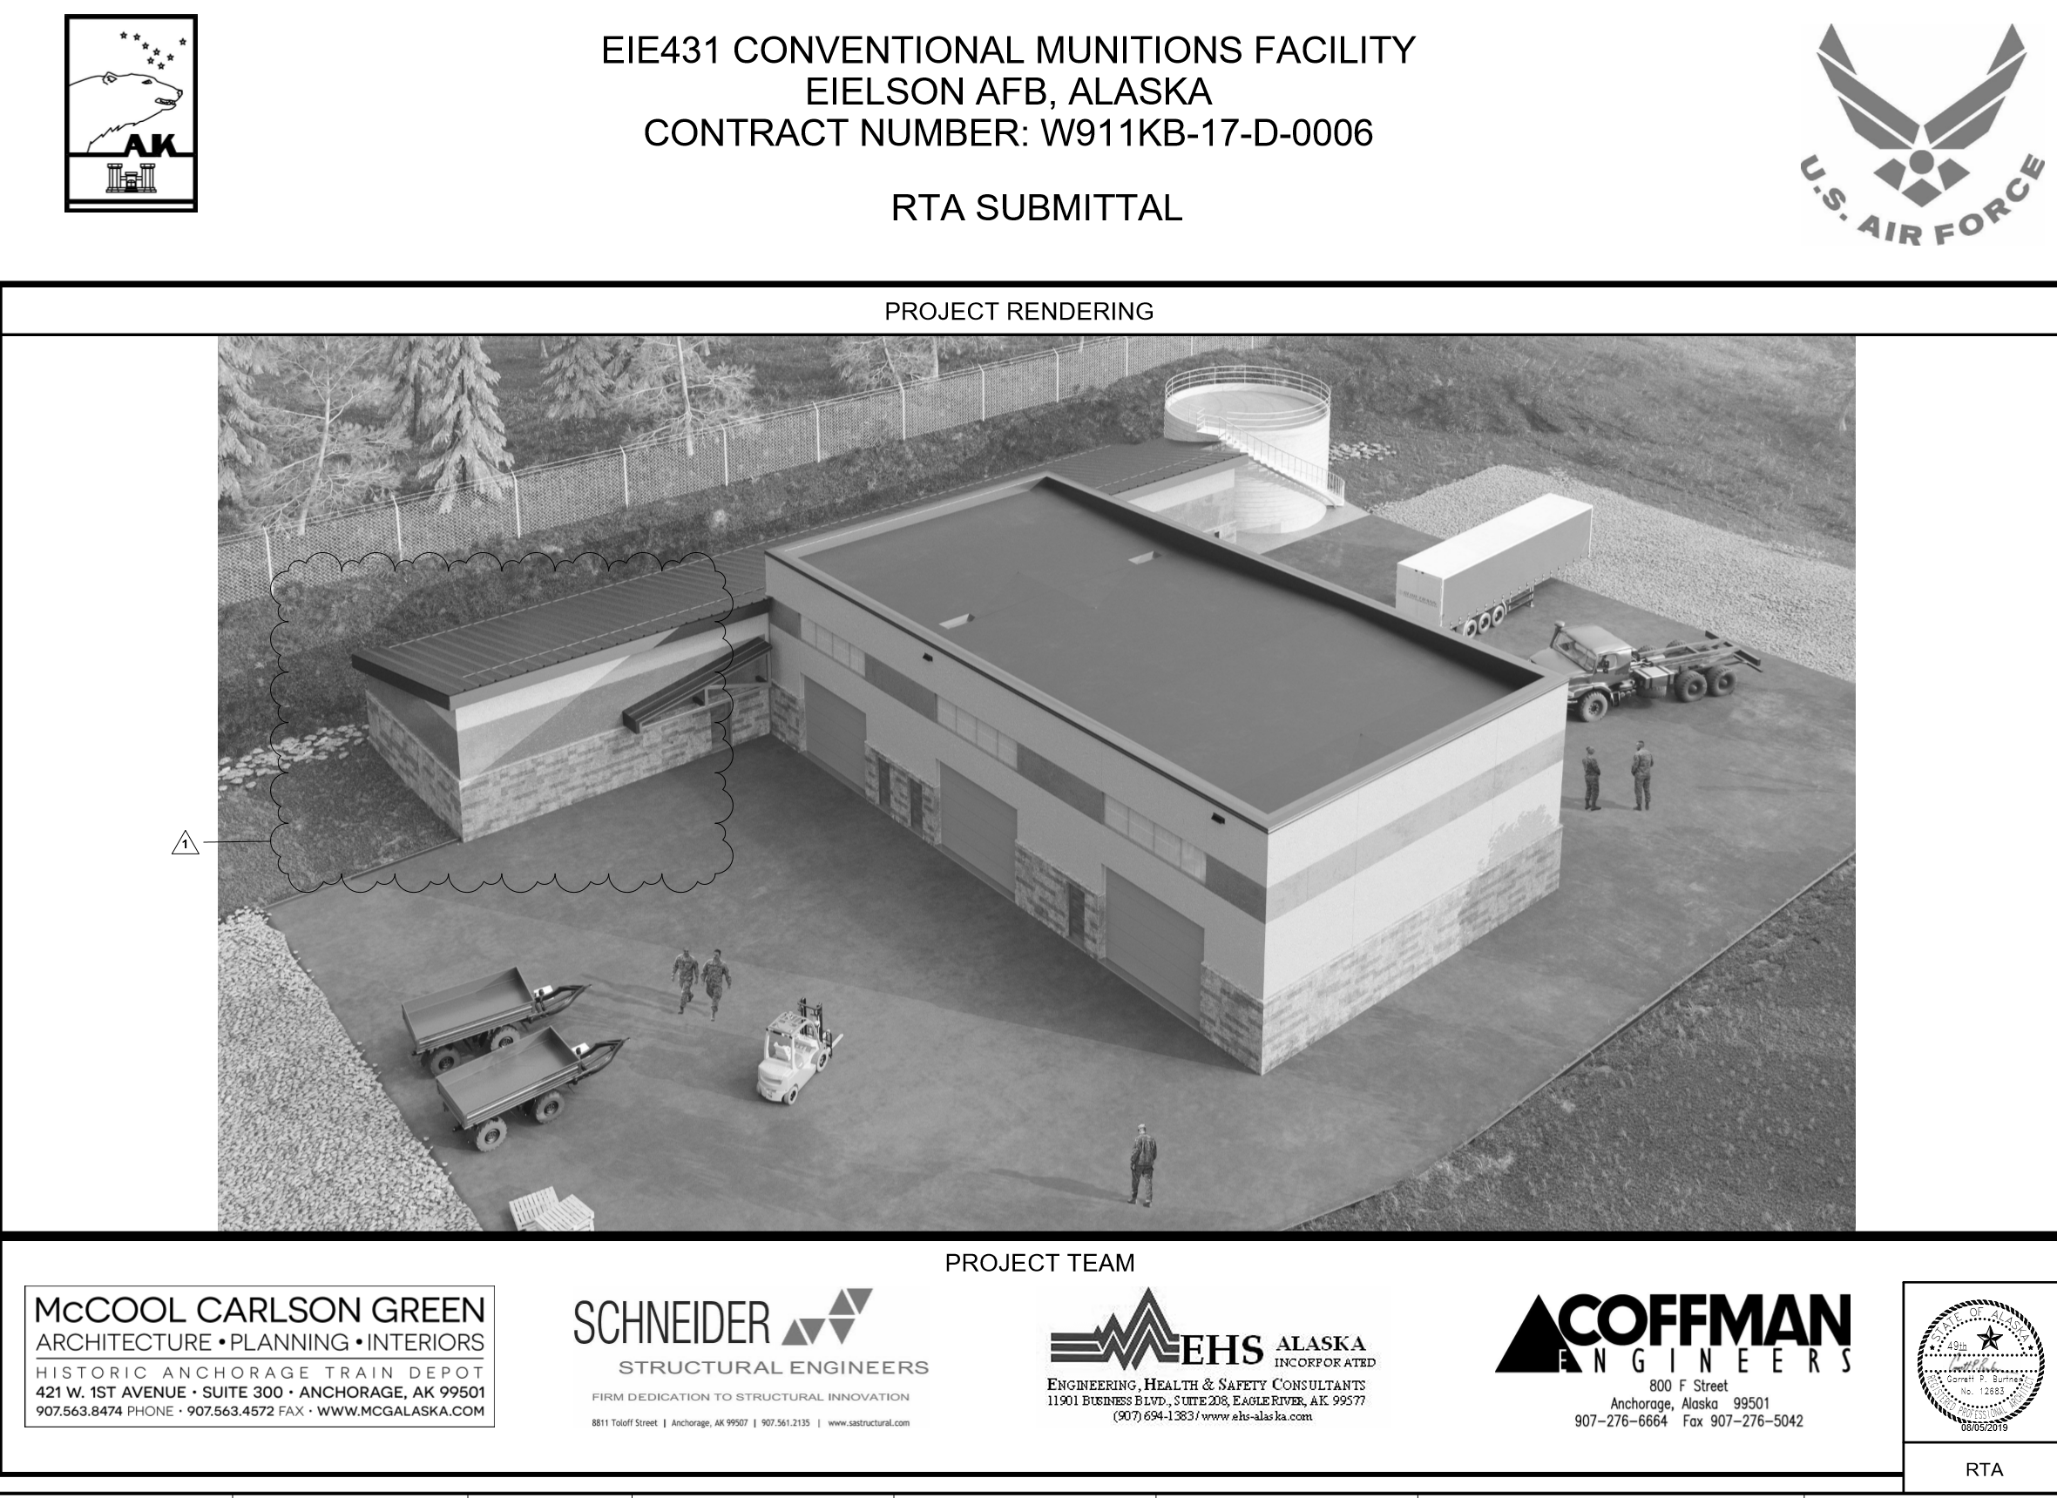
General Contractor Narrative: ASRC Builders, LLC. General Contractor (Karen Hilliard)
3900 C Street Suite 303 Anchorage, AK 99503 United States
ASRC is the largest Alaska-owned and operated company and the largest private employer in the state. ASRC is a multi-billion-dollar company that operates in six diverse lines of business: government contract services, petroleum refining and marketing, energy support services, industrial services, construction and resource development. ASRC has been building in Alaska for over 45 years. ASRC provides CM/ GC services for projects from $5 million to $215 million. ASRC is a DOT Disadvantaged Business Entity (DBE) & SBA 8(a) Disadvantaged Small Business Program participant. With no debt and access to funding for phased or long-term projects, ASRC Construction is among the most stable and secured construction groups in the industry. ASRC’s annual revenues exceed $3 billion and the corporation has a worldwide workforce of over 13,000 across multiple unique lines of business. ASRA has $300 million bonding capacity, $2.6 billion in construction work completed in last 20 years, and $45 million in company-owned fleet assets. ASRC Construction promotes a “Zero Incident” culture that encourages safe behavior and creates safe work environments and has a Total Recordable Incident Rate (TRIR) consistently below national average with nearly 1 million manhours worked per year.
The general contractor (GC) is responsible to plan, coordinate, budget, and oversee all aspects of the build. The general contractor must be a good communicator and skilled time manager. To be efficient the general contractor must also be detail oriented and proficient at managing personnel and the budget. Multitasking and creativity are important aspects to project completion. The daily site supervision is provided by the GC or project management personnel as well providing site safety, coordination, communication, and scheduling with subcontractors, vendors, architects and engineers, as well as the owner.
General Contractor Responsibilities:
- Obtaining all construction permits
- Obtaining bids for Subcontracted work
- Provides bonds and insurance for contracted work
- Provides temporary utilities
- Provides site security to prevent unauthorized use
- Ensures building meets required code
- Providing scaffolding for trades and ensure site safety and usage
- Ensures construction materials meet specifications and tests for compliance
- Ensures site is kept clean and in order for site safety
- Determines material placement sites
- Reviews schedule and communicates changes with owner
- Provides all material, labor, equipment required for construction
- Manages workers on site
- Balances cost of project and maintains financing records
- Provides waste disposal
- Monitors cash flows
- Provides site surveying and engineering
- Ensures licensing, bonding, and insurance provided by subcontractor

Sub-contractor #1: Excavation Contractor
Presented by: (Darci Chambers)
Detailed Role & Scope:
The excavation contractors work shall include all labor, material, equipment, and services required, as described or inferred in the contract documents. The excavation contractor agrees to do all work in accordance with the plans, specifications, and performance standards and in accordance with good building practice, any and all civic, municipal, provincial, and federal laws and codes pertaining thereto and to the satisfaction of the owner. The contractor obtains or will obtain all licenses required in connection with their work. The contractor is responsible for maintaining general site conditions and shall conform to the general site maintenance standards listed in the contract documents. The excavation contractor shall excavate all material in accordance with the geo-technical site plans and as may be required by the geo-technical engineer and the owner. All excavation work shall be done in accordance with the U.S. Department of labor and OSHA. The excavation subcontractor must visit the site prior to the start of work to become familiar with the existing conditions, limitations, and any features that may affect the proposed excavation. All earthwork shall follow the storm water pollution prevention plan described in the construction documents. The excavation contractor is not responsible for providing horizontal and vertical control surveying.

Sub-contractor #2: Concrete Contractor
Presented by: (Kellie Boling)
Detailed Role & Scope:

Sub-contractor #3: Structural Steel Contractor
Presented by: (Shane Darrow)
Detailed Role & Scope:

Sub-contractor #4: Electrical Contractor
Presented by: (Derek Hileman)
Detailed Role & Scope:
Electrical contractor shall be responsible for the demolition of any current existing electrical infrastructure, maintain temporary power for construction phases, and the installation of new electrical components of the project per drawings and specifications provided. Electrical contractor shall also coordinate any systems needed with the Mechanical contractor to complete project fully. Electrical shall be fully licensed and insured by the state of Alaska standards and shall comply with all local, state, and federal code compliance.
Scope of work included but not limited to:
- Demolition and disposal of all existing electrical components on site
- Temporary power installation for construction only
- Transformer installation
- Main power distribution to building internal
- Internal individual power distribution
- Coordination of power to specialty mechanical equipment

Sub-contractor #5: Mechanical Contractor
Presented by: (Cierra Vondohlen)
Detailed Role & Scope:
Mechanical Contractor shall be responsible for the demolition of any existing mechanical equipment and fictures. Mechanical Contractor shall furnish ductwork, piping offsets, fittings, and accessories as required to provide a complete installation. Coordinate the work of the different trades to avoid interference between piping, equipment, structural, and electrical work. Provide complete, in place, all necessary offsets in piping and ductwork, and all fittings, and other components, required to install the work as indicated and specified. Mechanical Contractor shall be fully licensed and insured by the state of Alaska standards and shall comply with all local, state, and federal code compliance.

